

sYStem desiGn acceptance

PowerApps (e-Leave Applications)

Version 2.0



February 26, 2020

Sistem rkk sdn bhd

February 26, 2020

Sistem rkk sdn bhd

Table of Contents

Site eleave 3

Design for site collection 3

Details of site collection 3

Power Apps (e-Leave Application) 4

Menu Page 4

User 5

Dashboard Page 5

e-Leave Request 7

Cancel e-Leave Request 8

Leave Balance 9

Approver 10

Dashboard Page 10

Approval Task 11

Admin 12

Flows 14

Agreement 15

# Site eleave

## Design for site collection

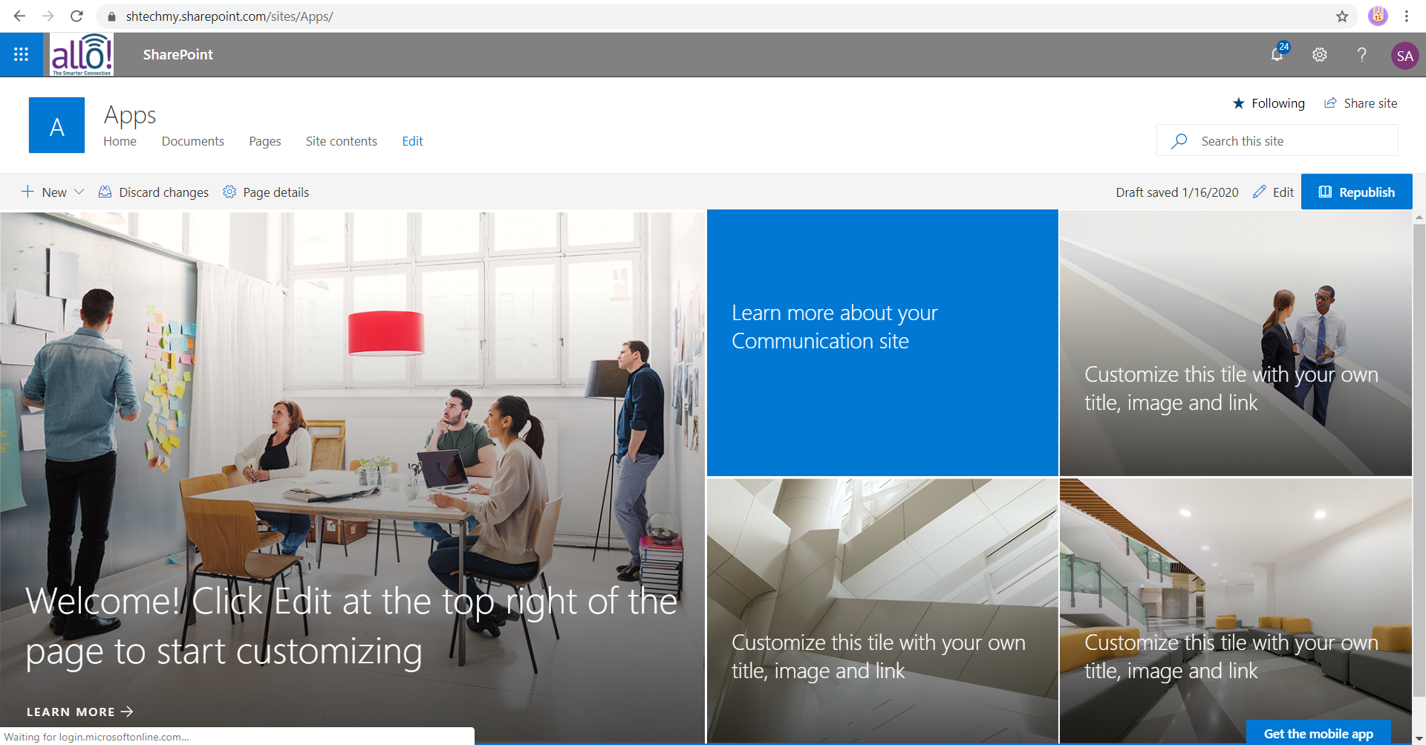

## Details of site collection

|  |  |
| --- | --- |
| TITLE | DETAILS |
| Site Collection Name | Apps |
| Site Collection URL | <https://allotech.sharepoint.com/sites/Apps/> |
| Type of site | Communication sites |
| Logo | Allo Technology Sdn Bhd |
| Top Navigation | Link navigation to:   * Home – direct to the home page which is tenant name * eLeave Application – Direct open the eleave application using * HR Application - Direct open the HR application using * Master List – Direct to all list required for this apps |
| Subsite | * Eleave - <https://allotech.sharepoint.com/sites/Apps/eleave> |
| Footer | Copyright @ Allo Technology Sdn Bhd |

# Power Apps (e-Leave Application)

## Menu Page

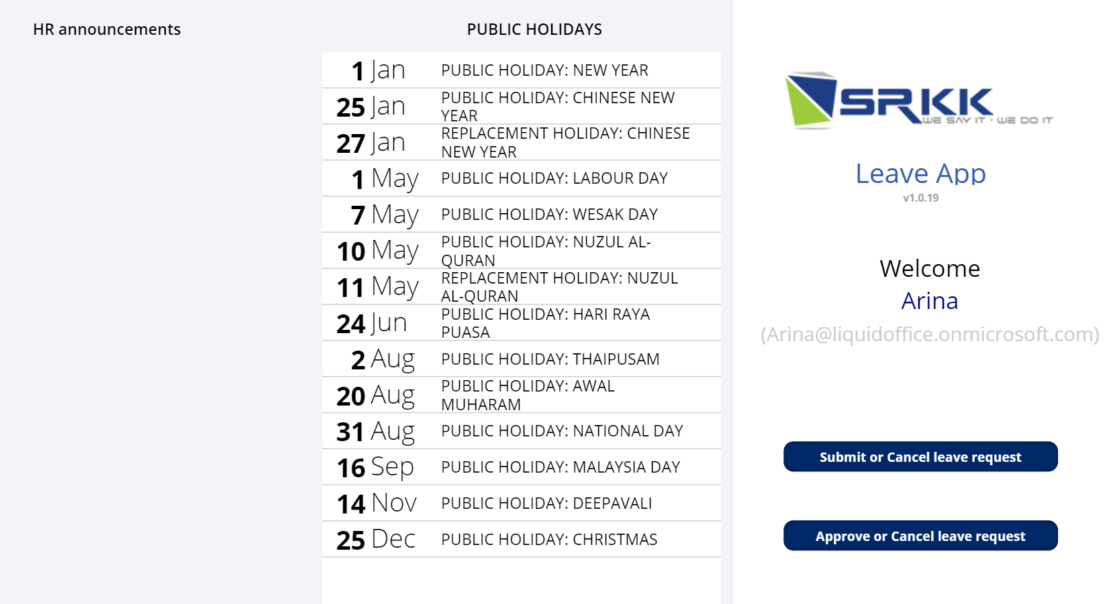

3

2

1

|  |  |  |  |
| --- | --- | --- | --- |
| No. | Part | Functionality | Remarks |
|  | HR Announcements | * Display announcement from HR | * Rename the HR Announcement to “ALLO Technology Sdn Bhd Announcements” * Display the latest announcement on the top * Set 5 announcement only can display at once time |
|  | Public Holiday | * Display all list of public holidays from the master list * Sort by date in ascending order | * Change the arrangement public holidays to column number 3 (to left) |
|  | Company and User Details | **Display Information**   * Logo * Title * Version * Welcome Text * Name * Email   **Button:**   * Submit or Cancel leave request * Approve or Cancel leave request | * Change the arrangement eleave application to column number 2 (to middle) * Logo change to ALLO Technology Sdn Bhd. * Replace the blue color background in button to purple (#652c8b) * Rename the button to “User” for Submit or cancel leave request * Rename the button to “Intermediate Manager/CEO” for Approve or cancel leave request |

## User

### Dashboard Page

Users will be re-directed to the dashboard that contains history of the users’ submitted eLeave applications

1

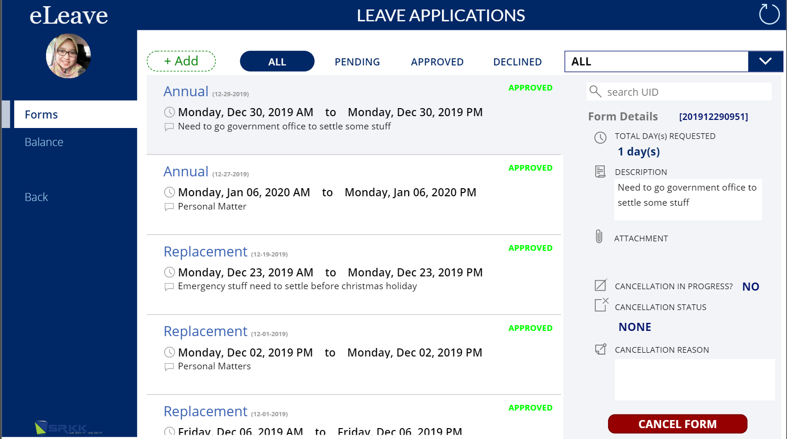

4

5

23

3

|  |  |  |  |
| --- | --- | --- | --- |
| No. | Part | Functionality | Remarks |
|  | Navigation | **Display Information**   * Title of the application * Picture (from O365 Profile)   **Button**   * Forms: Details of leave application * Balance: Show the leave balance based on the current user * Back: Navigate back to the menu page |  |
|  | Status | The tabs denote the status of each request, whether the requests are **Pending** (color: orange), **Approved** (color: green) or **Declined** (color: red).  **Tabs Button**   * **+ Add**: Create a new leave * **All**: Display all the leave status * **Pending**: Display all the pending leave for approval only * **Approved**: Display all the approved leave only * **Declined**: Display all the declined leave by approver only | * Change the text color for the “Approved” status to blue. |
|  | Gallery | **Display details of leave**   * Leave Type * Date Apply Leave * Date of Leave * Reason * Status |  |
|  | Search | Select by leave type |  |
|  | Cancellation form | **Show the details of cancellation leave**   * ID Leave * Total day requested * Description * Attachment * Status cancellation in Progress * Cancellation Status * Cancelation reason   **Button**   * Cancel form: Show popup message to get confirmation to cancel the leave with the reason |  |

### e-Leave Request

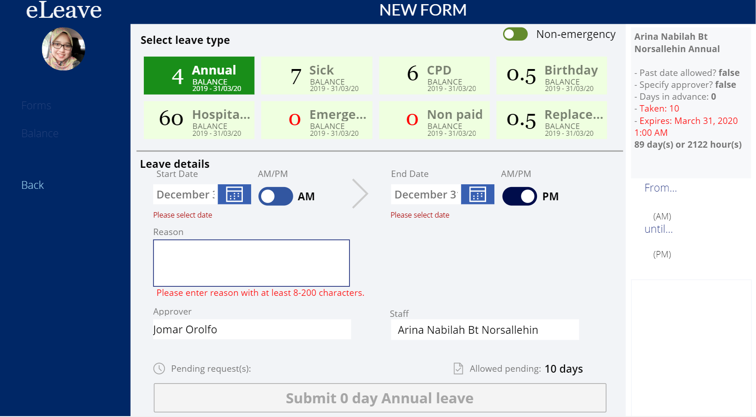

9

8

7

6

5

4

3

2

1

2

1

|  |  |  |  |
| --- | --- | --- | --- |
| No. | Part | Functionality | Remarks |
|  | New Form | Step for user to create new e-leave   1. Select the leave type: -    * Annual    * Sick    * CPD    * Birthday    * Hospital    * Emergency    * Non- paid    * Replacement 2. Check box to mention the urgency of the leave to get the approval 3. Select the start date and set the time 4. Select the end date and set the time 5. Fill up the reason for applying leave 6. Show the approver name 7. Display the requestor name 8. Display the allowed days to apply the leave 9. Submit button to start the approval process    * Auto count the total leave and display on button | * Every user can change the allowed pending number |
|  | Application Policy | **Display information**   * Past date allowed * Specified approver * Days in advance * Total Taken Leave * Expires Date of leave balance * Show the total days and hours to expired |  |

### Cancel e-Leave Request



1

|  |  |  |  |
| --- | --- | --- | --- |
| No. | Part | Functionality | Remarks |
|  | Cancel Form | Step for user to cancel e-leave   1. Select **cancel form** on the intended leave request. 2. Click on cancel form to cancel the leave request. 3. A message will display to confirm the cancellation of the leave form.     5  4   1. The text field for **Cancellation reason** is mandatory. 2. Once confirmed, the cancellation process will commence | * Close Button change to capital words (CLOSE) |

### Leave Balance

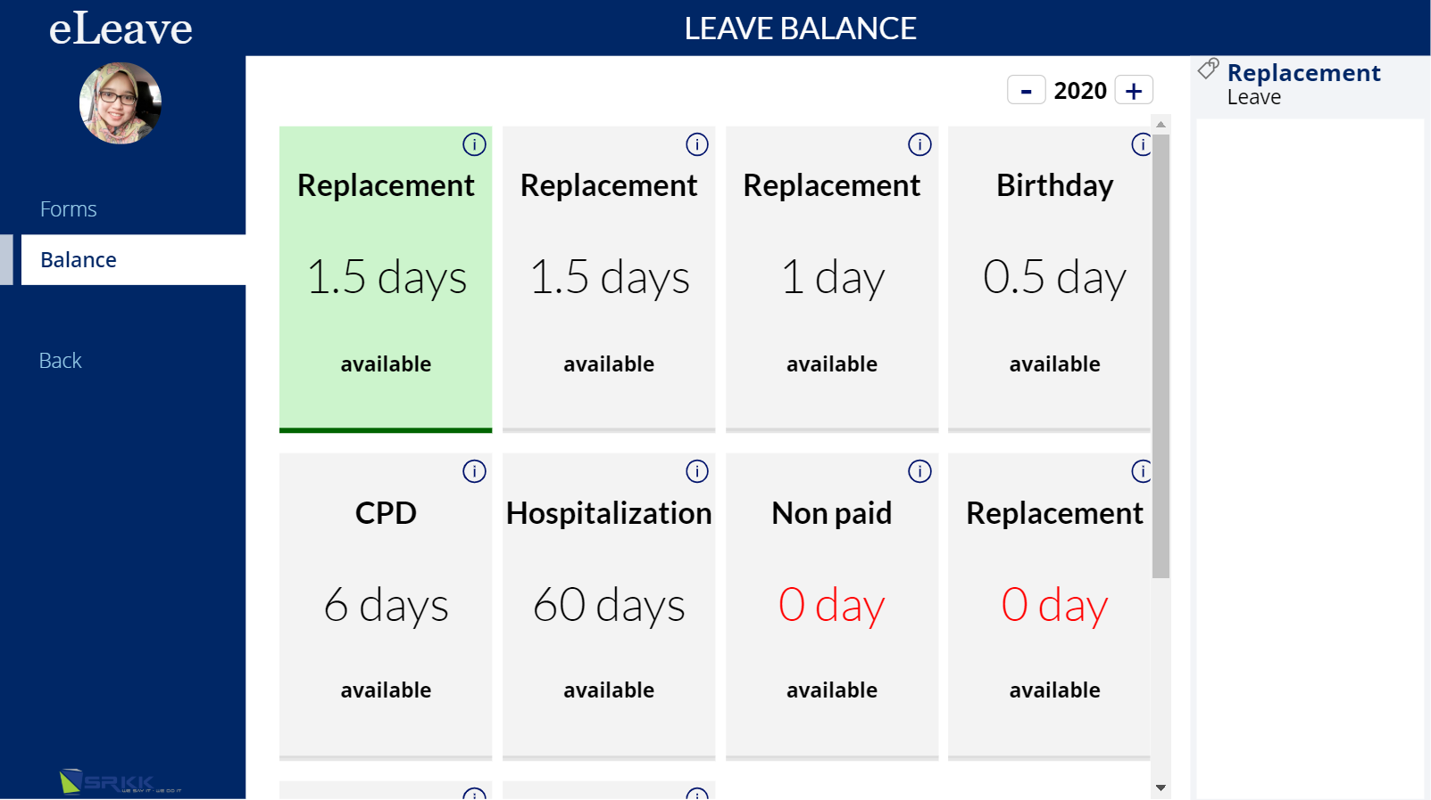

3

1

2

|  |  |  |  |
| --- | --- | --- | --- |
| No. | Part | Functionality | Remarks |
|  | Category of leave | Display all the category leave updated with the remainder days available for users to apply |  |
|  | Info icon | View the details of category of leave. |  |
|  | Individual leave | View the list of submitted leave applications under that leave category. |  |

## Approver

### Dashboard Page

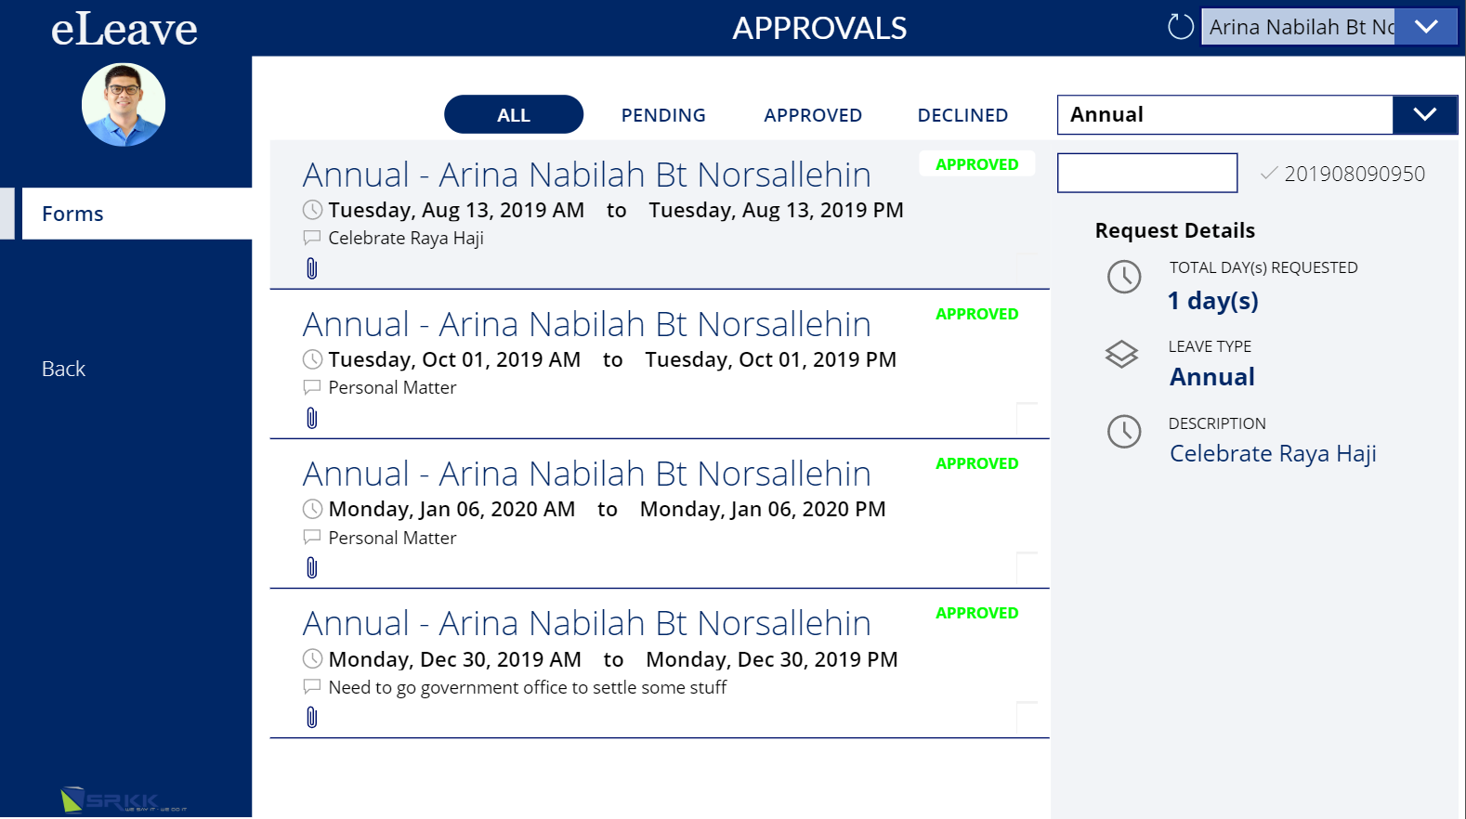

|  |  |  |  |
| --- | --- | --- | --- |
| No. | Part | Functionality | Remarks |
|  | Gallery | Display all the task for approval based on the status   * Leave Type * Requestor * Start Date * End Date * Reason * Status * Attachment |  |
|  | Search | Filter based on the leave type only |  |
|  | Request Details | Display details based on the selection items   * Total days requested * Leave Type * Reason |  |

### Approval Task

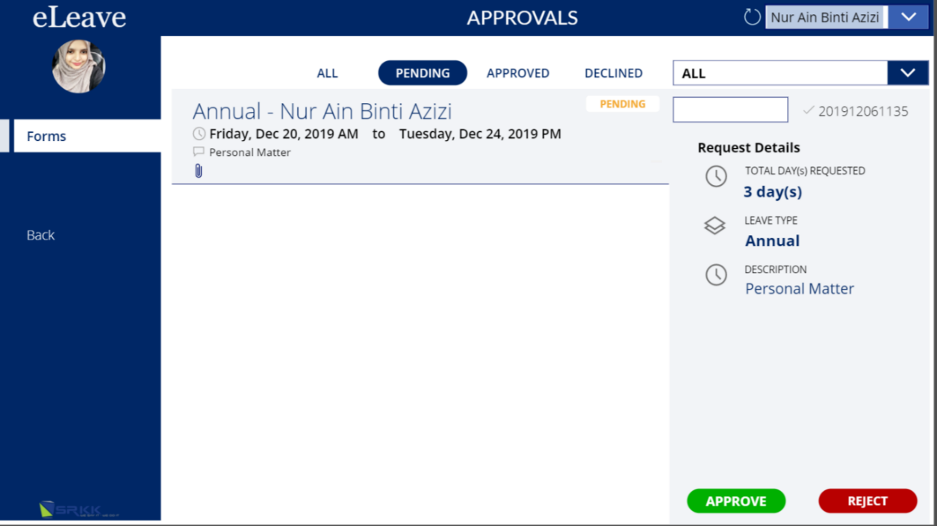

4

3

2

1

|  |  |  |  |
| --- | --- | --- | --- |
| No. | Part | Functionality | Remarks |
|  | Task Form | To approve by user:   1. Managers will need to select a user from the dropdown menu on the top-right corner of the page. 2. When a particular user is selected, their eLeave history as well as their pending requests are displayed. 3. Select the eLeave application for approval and the leave request details will be shown on the right pane. 4. Select the green **Approve** button; or red **Reject** button on the bottom-right panel. 5. Any action will send an email to the requester to update on the current status of the eLeave application. |  |

## Admin

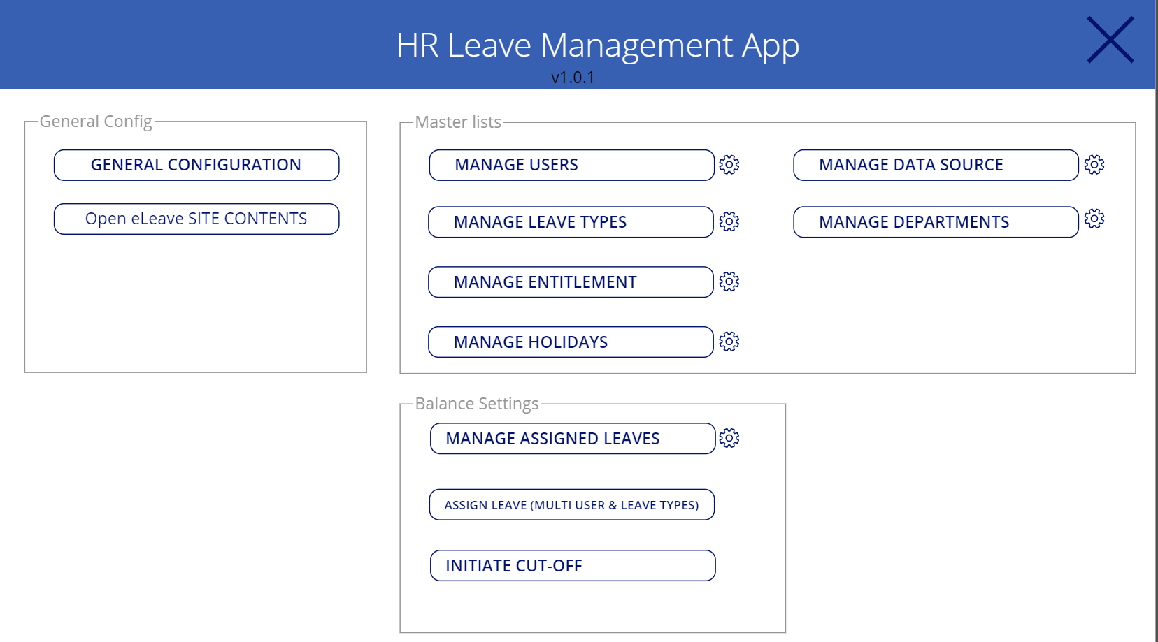

|  |  |  |  |
| --- | --- | --- | --- |
| No. | Part | Functionality | Remarks |
|  | General Config | **Button: General Configuration**   * Link to manage the configuration based on the business requirement   **Button: Open e-Leave Site Contents**   * Link to Site content in SharePoint | Set the general configuration to:   * Am/pm - Yes * First approval - Yes * 2nd approval - To be confirmed * Limit leave days - No * Max pending leave days - 20 |
|  | Master List | **Manage User**   * Link to create a new user in company   **Manage Leave Types**   * Link to add/update leave type   **Manage Entitlement**   * Link to manage the total leave based on the job level   **Manage Holidays**   * Link to add/update leave for holiday   **Manage Data Source**   * Link to manage type of leave   **Manage Departments**   * Link to add/update a department |  |
|  | Balance Settings | **Manage Assign Leaves**   * Link to assign leave for each user   **Assigned Leave (Multiuser & Leave Types**   * Link to assign leave for multiple user   **Initiate cut – off**   * Set expires date for e-leave application |  |

# Flows

|  |
| --- |
|  |
| Remarks: |

# Agreement

|  |  |
| --- | --- |
| **Prepared on** | 26 February 2020 |
| **Sign-Off by Customer** | Sign-Off by SRKK consultant |
| Name:  Signature:  Date: | Name:  Signature:  Date: |
| Name:  Signature:  Date: | Name:  Signature:  Date: |
| Name:  Signature:  Date: | Name:  Signature:  Date: |
| Name:  Signature:  Date: | Name:  Signature:  Date: |